**PROJECT**

**TEAM –**

* KUNDURI SAI NIKHIL REDDY
* MUNIGANTI VENU

**SECTION –** M2

**Title** – House Hunt project

**Project Statement –**

* House Hunt is a real estate web application where users can search for rental properties, view property details, and book appointments with house owners to learn more about the properties they are interested in**.**
* Users can search for rental properties, view property details, and book appointments with property owners.
* Key features include property listings, property details pages, filter functionality, appointment booking, user profiles.

**Technology Used** – Django Python Web framework, Bootstrap

**Description –**

* This project mainly focuses on those who are looking for a new place to live. You sign up for House Hunt and log in. You start browsing through the listings, using filter to find exactly what you want. When you find a place you like, you click on it to see more details. If it looks good, you request an appointment to see it in person. The owner gets back to you, and you set up a time to visit. All your appointments and info are stored in your profile for easy access. And while you're doing all this, admins are making sure everything runs smoothly behind the scenes.

**Features –**

**Property Listings:**

Display available rental properties with essential information (location, price, type).

Users can browse and explore properties.

**Property Details Page:**

Show comprehensive details for each property.

Include high-quality image, property description, amenities, and owner contact information.

**Filter Functionality:**

Users can filter for properties based on type of property they are looking for.

**Appointment Booking:**

Users can request appointments to view properties.

Property owners receive appointment requests and can confirm or reschedule.

**User Profiles:**

Users create accounts, log in, and manage profiles.

View appointment history and saved favorite properties.

**Admin Panel:**

Admins manage property listings, user accounts, and appointment requests.

**Input- Output Design:**

1. **Input:**

A user visits the House Hunt website and wants to find a rental property

**Output:**

* The website displays a list of available rental properties with relevant information
* Each property listing includes required information such as location, price, and type.
* The user scrolls through the listings and clicks on a property for more details.

1. **Input:**

A user wants to learn more about a specific property.

**Output:**

* The website navigates to the property details page.
* The user is shown with all the property's information, including excellent photos, a description, a list of amenities, and the owner's contact data.

1. **Input:**

A user wants to learn more about a specific property.

**Output:**

* The user sees filter option such as property type on the property list page.
* The website modifies the filter results so that it only shows the property types that meet the chosen standards.

1. **Input:**

A user wants to book an appointment to view a property.

**Output:**

* The user clicks on a property listing from main page.
* The user navigates to the property details page.
* The user clicks on the "Book Appointment" button.
* The user fills out an appointment request form with their preferred date and time.
* The user submits the appointment request.

**UI Screens:**

**Main UI**

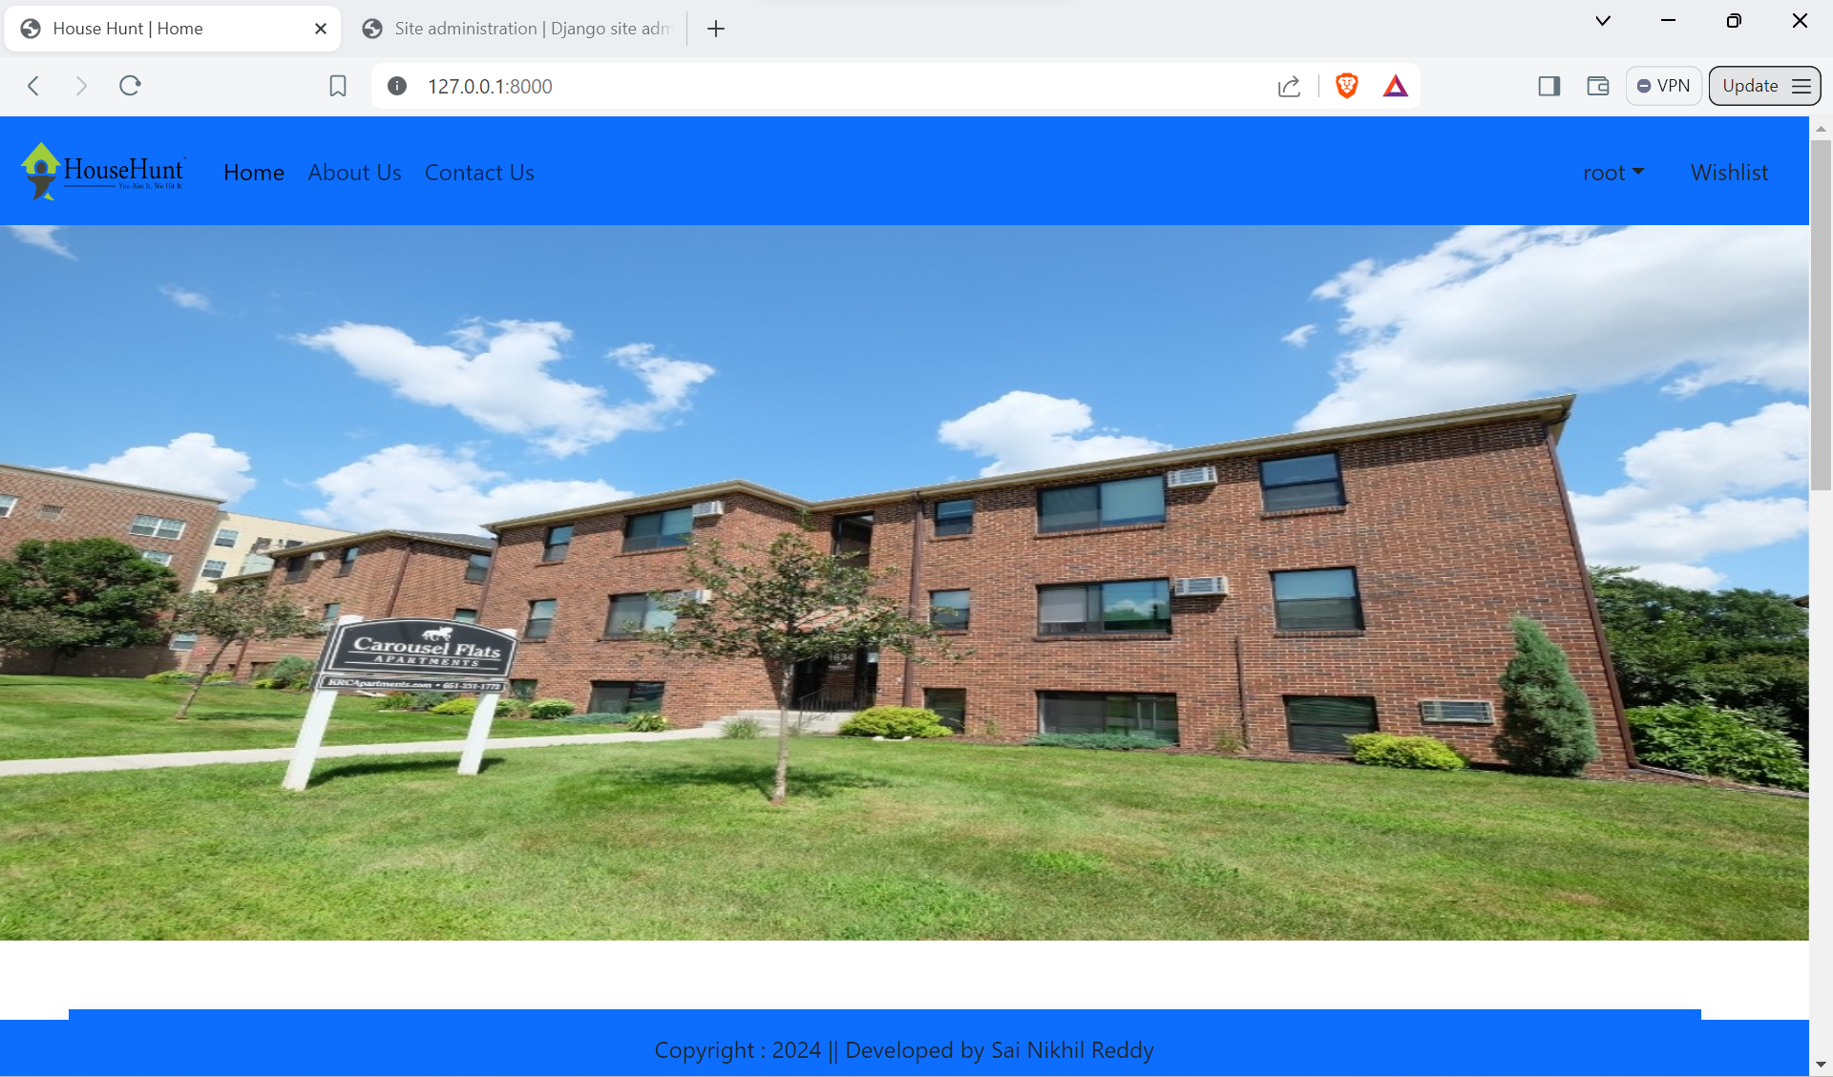

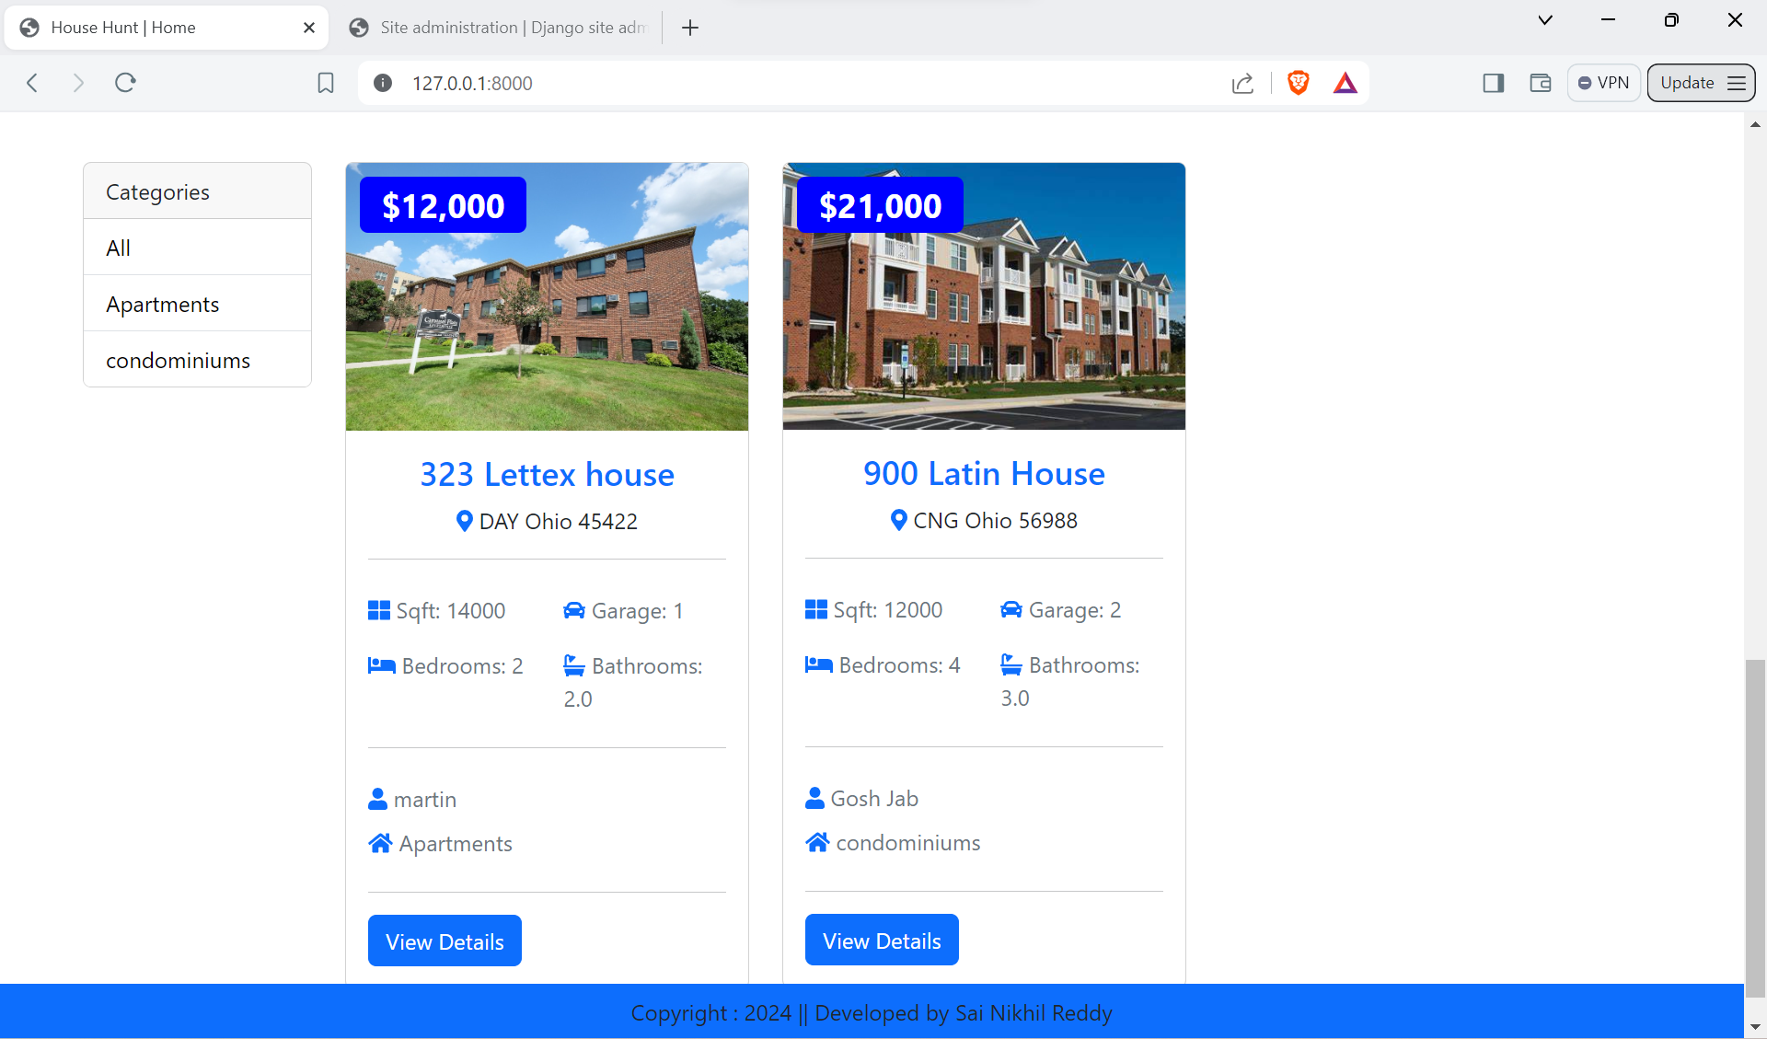

**View UI**

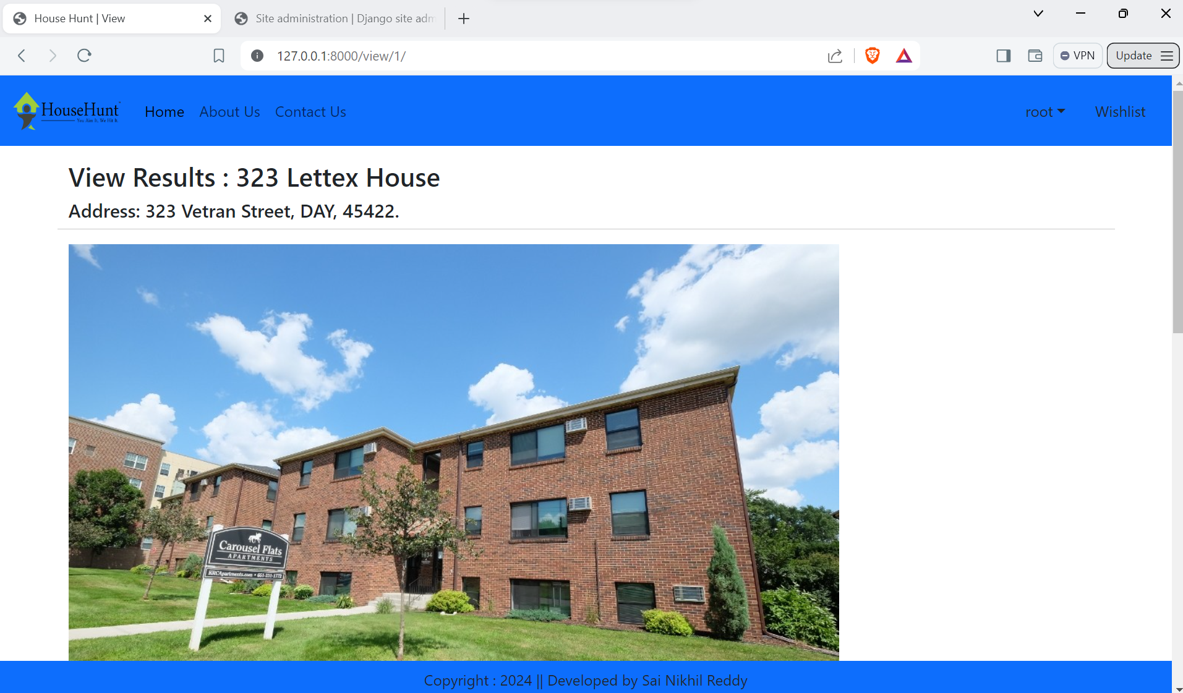

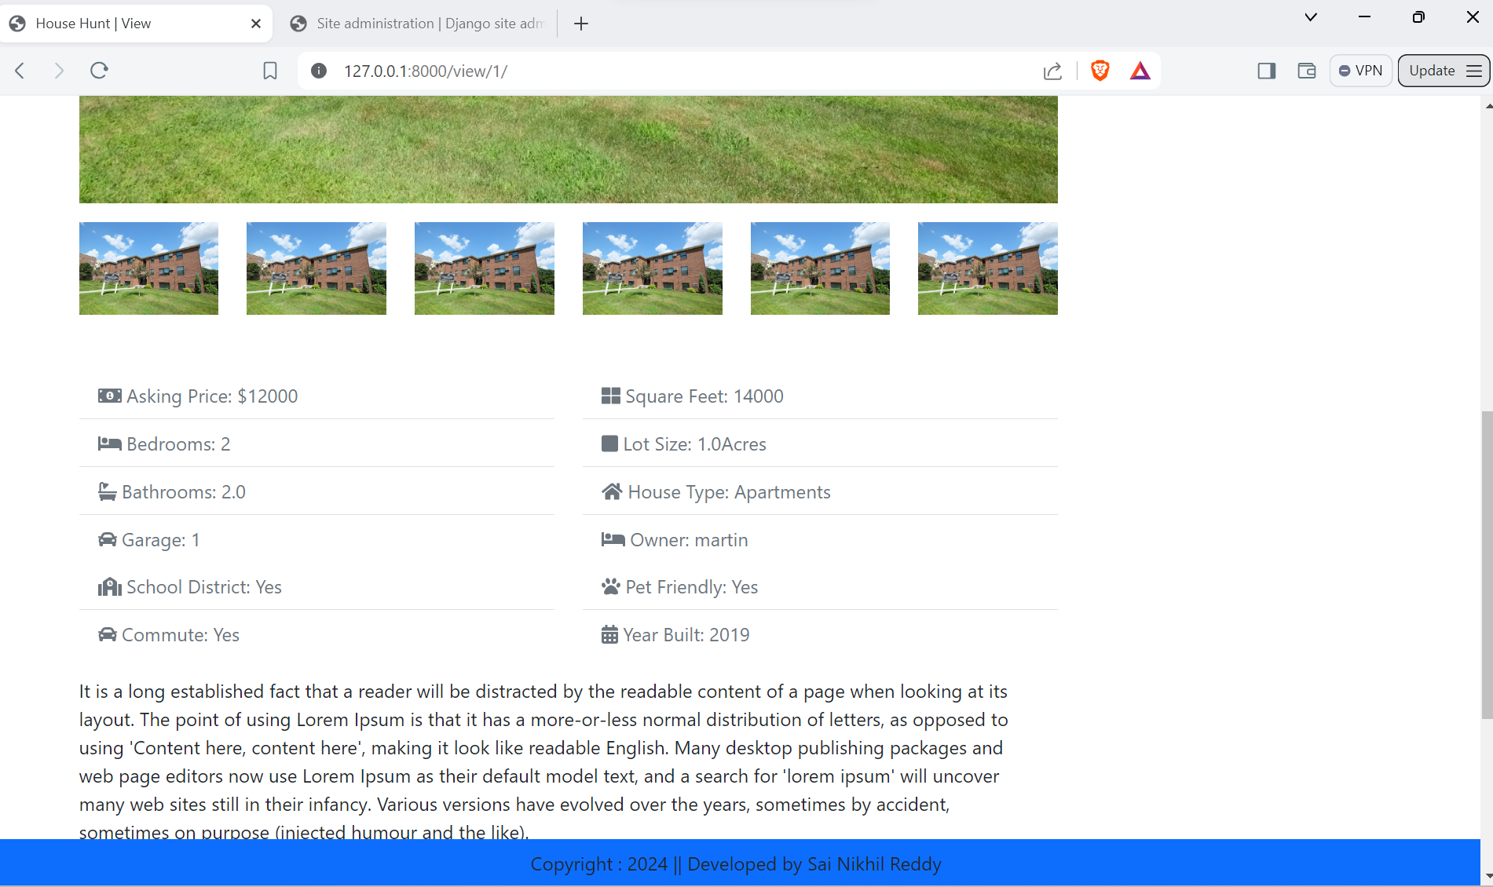

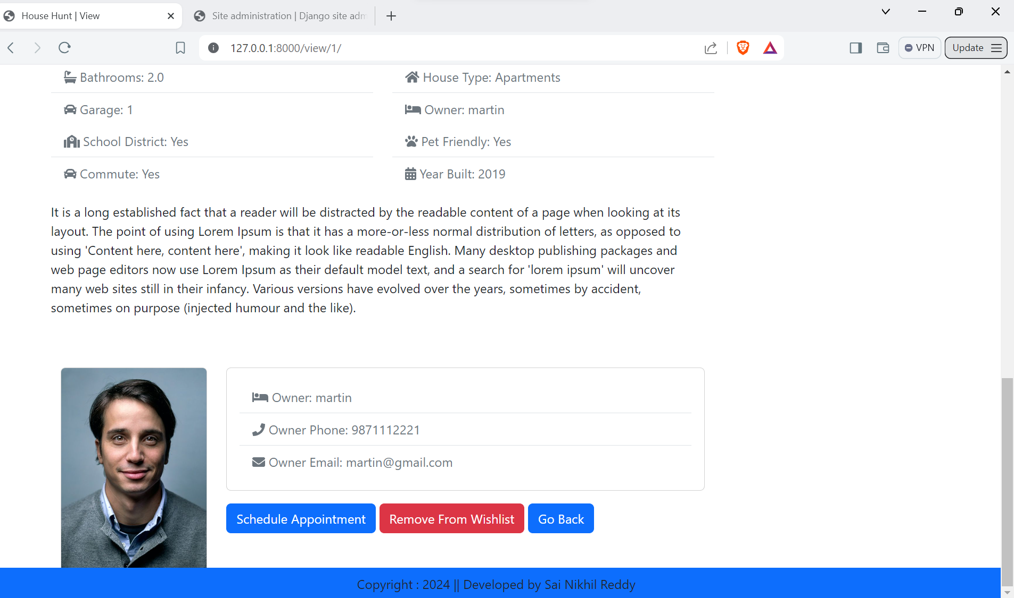

**Book Appointment UI**

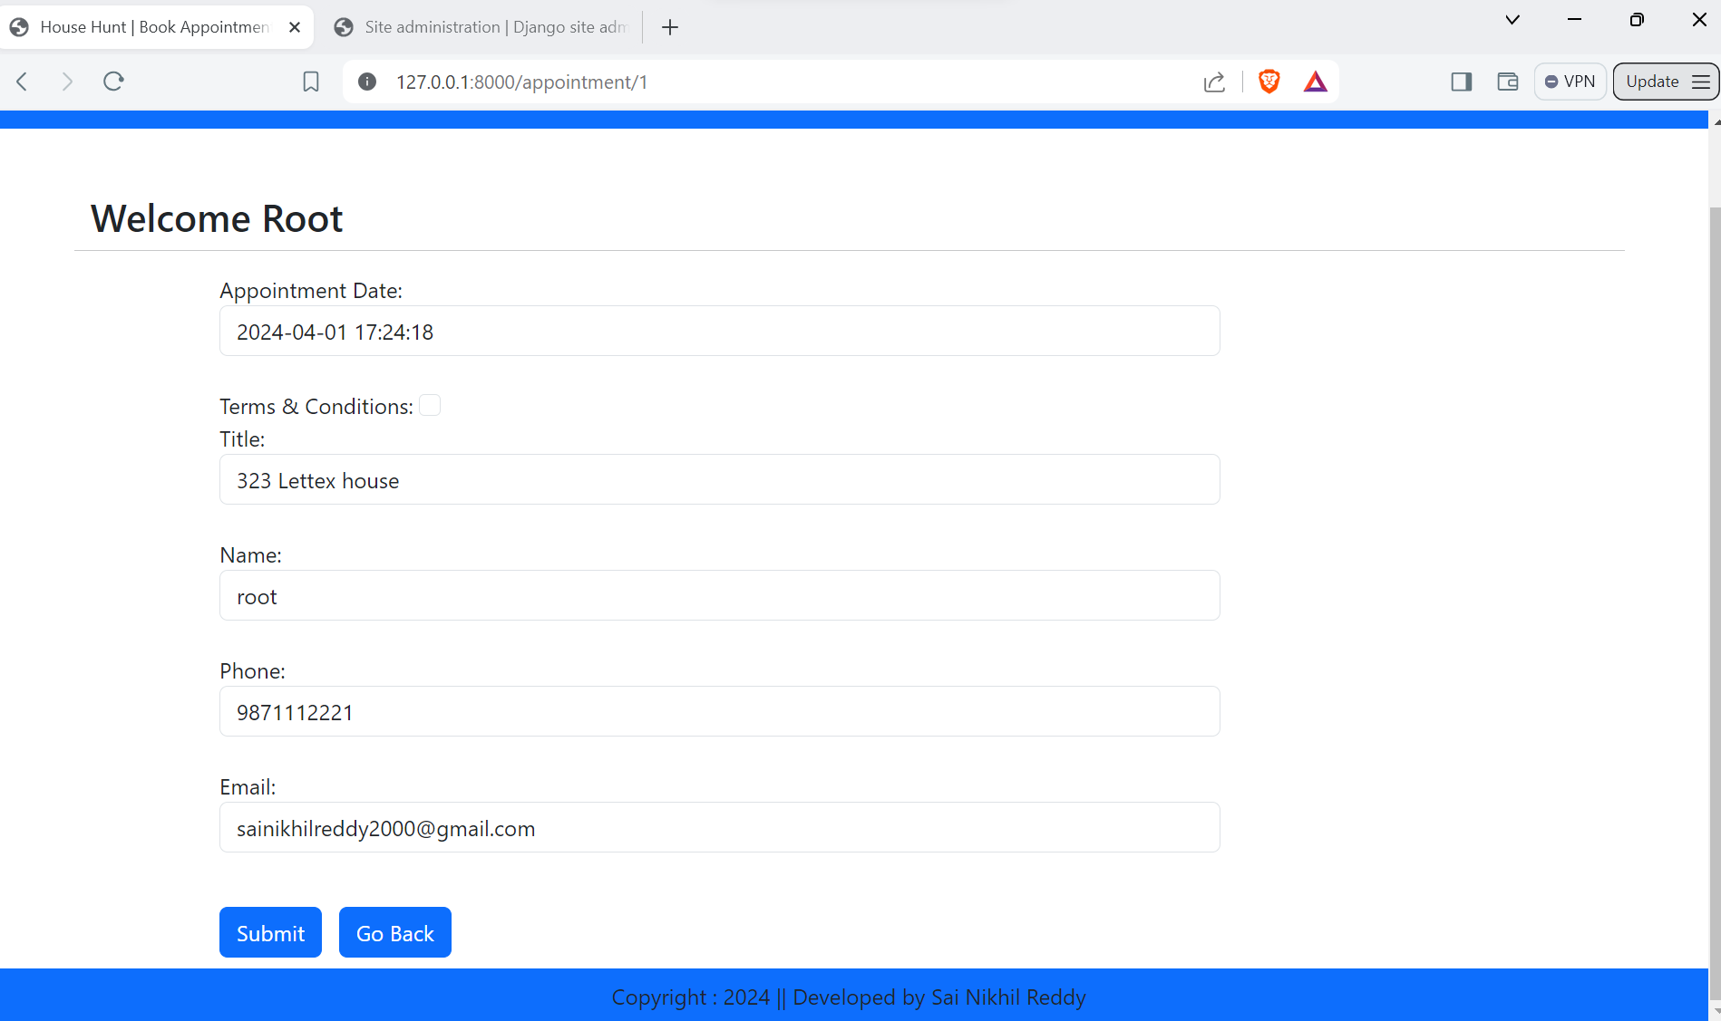

**View Appointments UI**

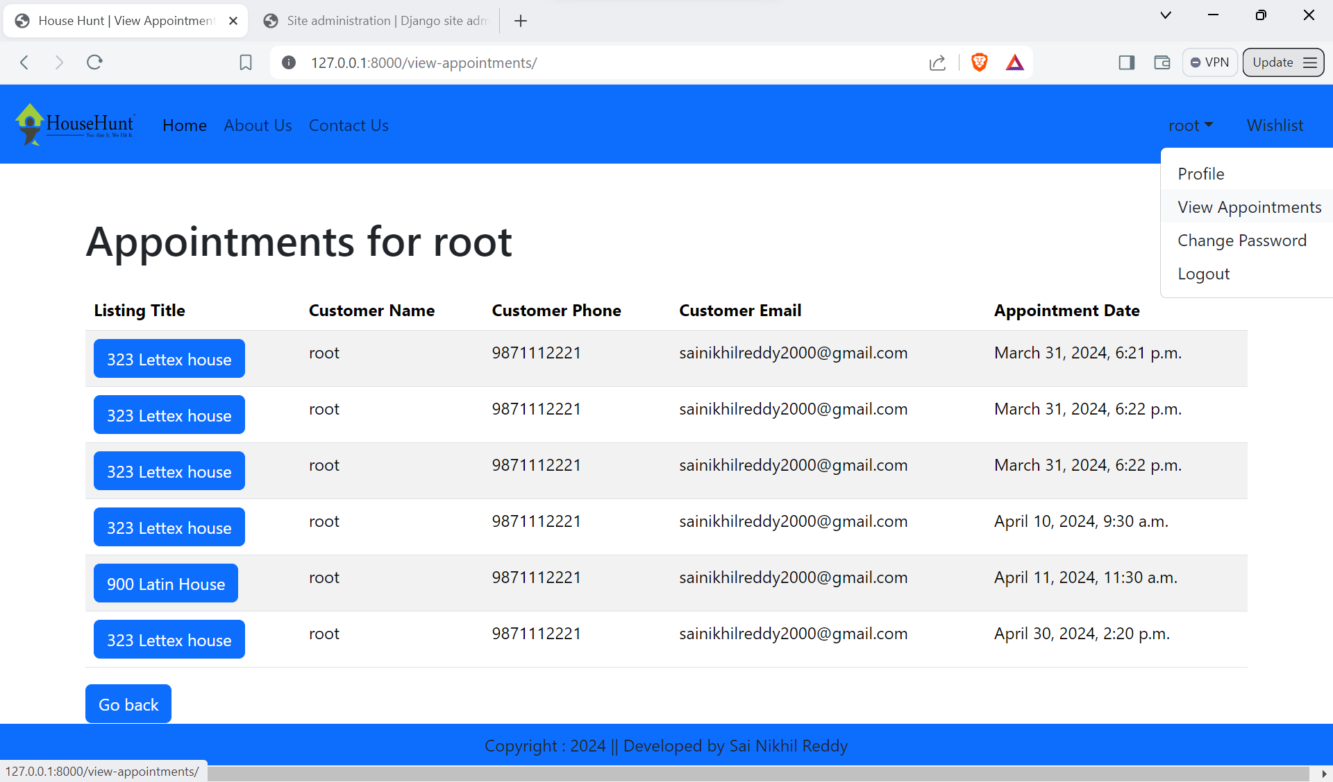

**Wishlist UI**

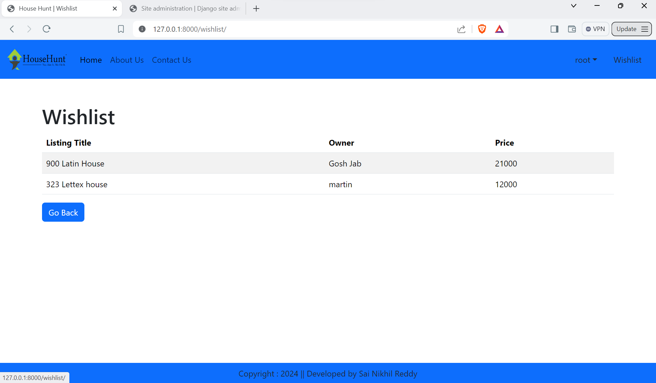

**Login UI**

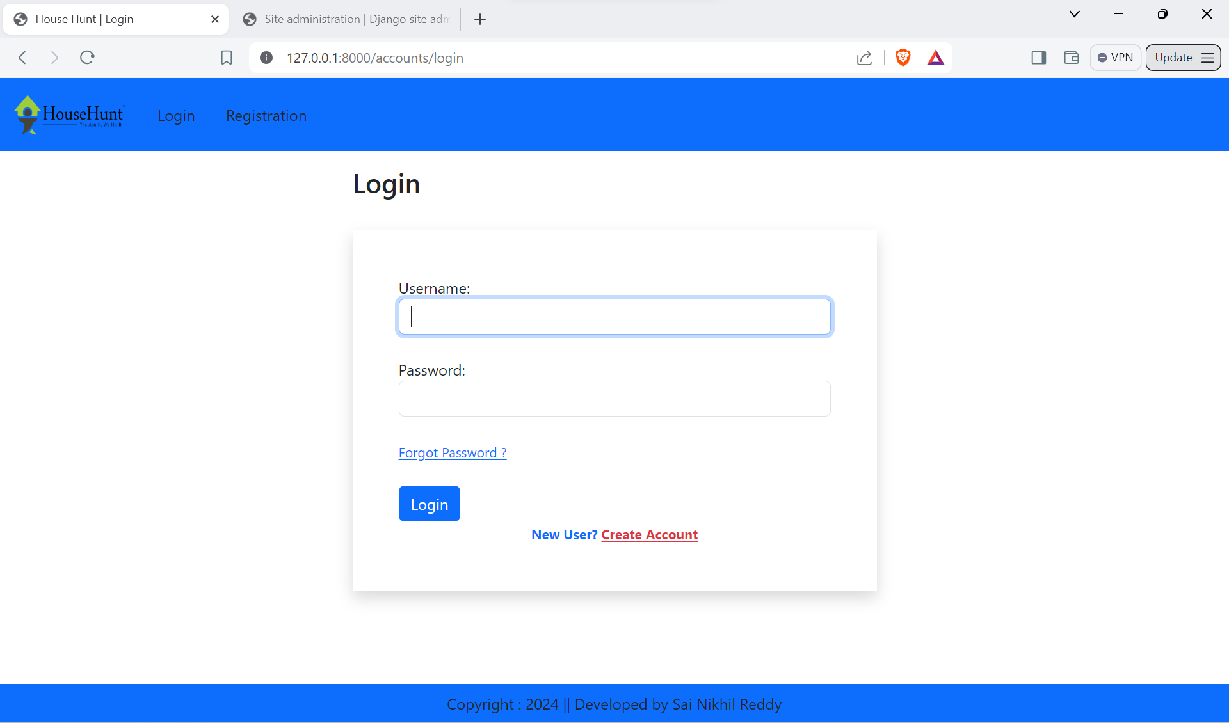

**Registration UI**

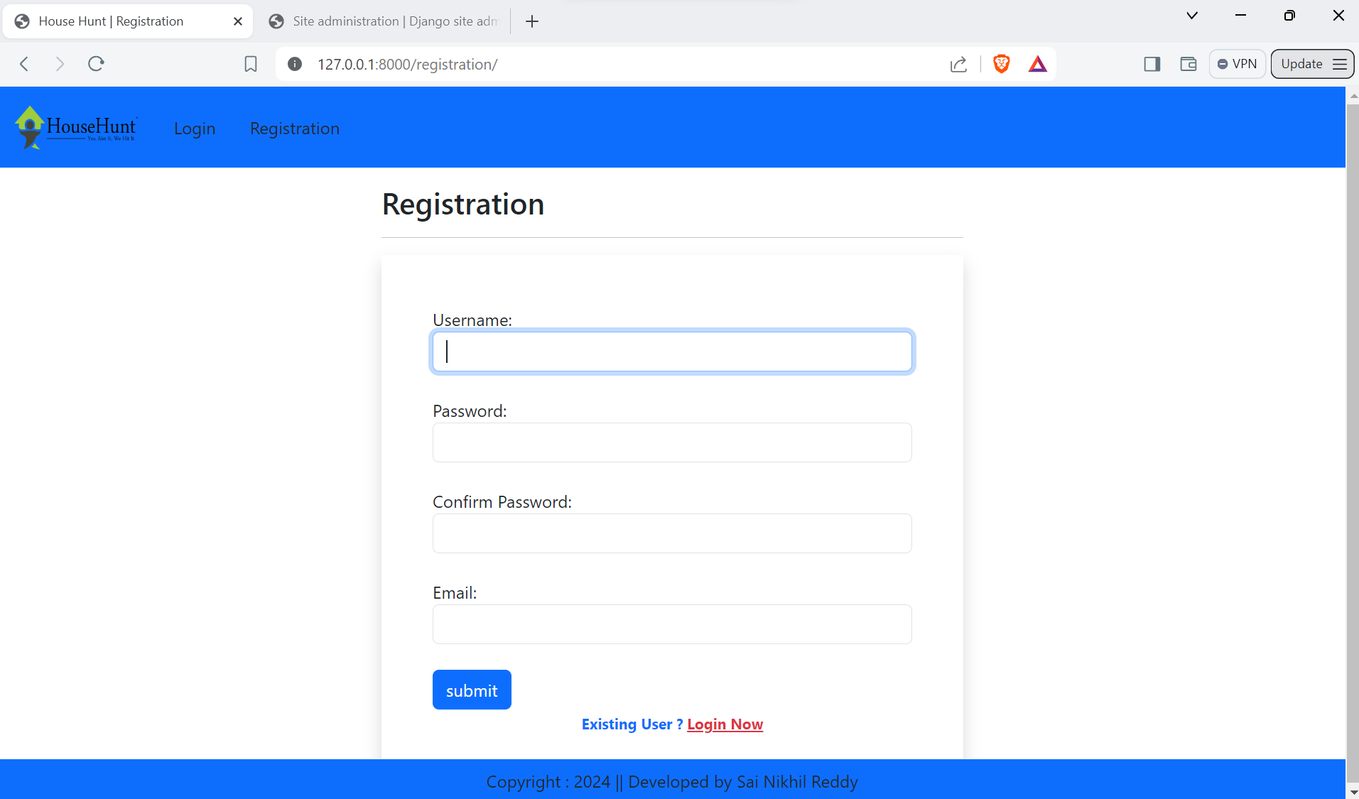

**Summary:**

House Hunt is a real estate web app where users can find rental properties, view details, book appointments, with key features including property listings, filtering, appointment booking, user profiles, managed through Django with Bootstrap for styling.